E-Huddle Security Assessment Report

The application contains multiple logic-level and access control vulnerabilities, including a critical code execution design flaw, insecure data exposure, and missing security controls.

Highest Risk Issue:
- Sandboxed Code Injection via Markdown Parser (CWE-94)

Vulnerability Findings:

1. Sandboxed Code Injection (CRITICAL)

Location:
Markdown parser handling $[...]$ expressions

Description:
The application evaluates user input inside a custom markdown syntax:
$[expression]
This results in dynamic execution of user-controlled input.
Although dangerous functions are blocked, this relies on blacklist filtering, which is inherently insecure.

Proof of Concept:
POST /api/posts
content=$[1+1]$

Result:
2
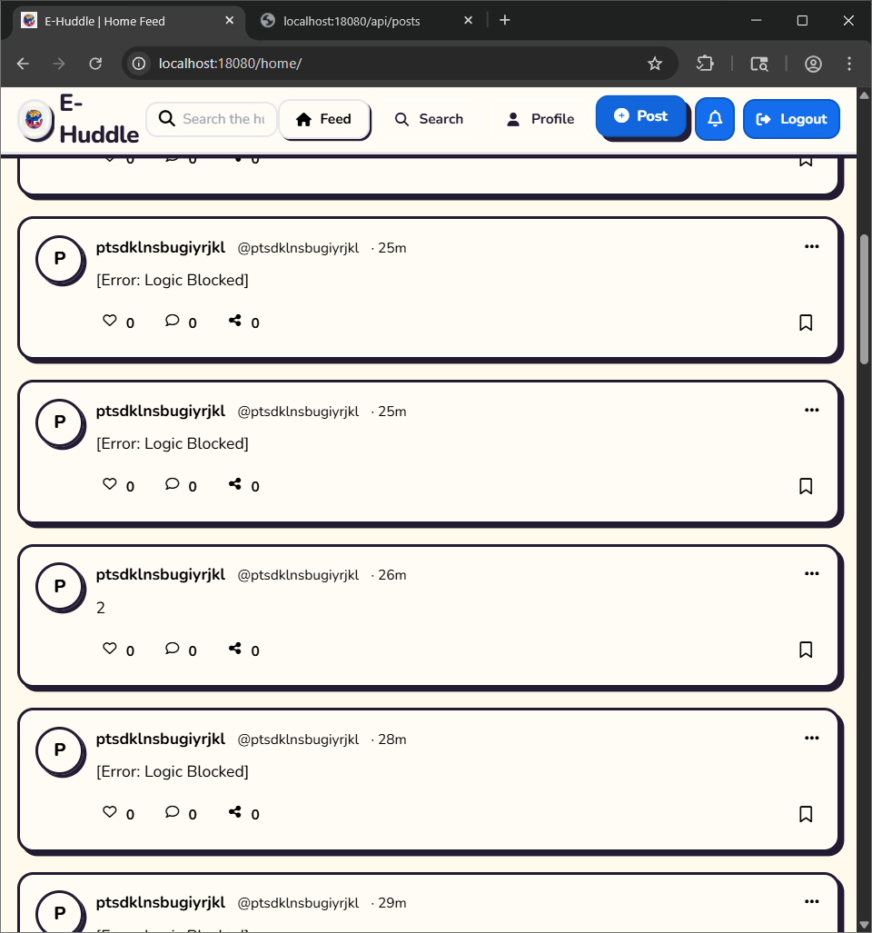
Impact:
- Arbitrary expression execution
- Potential sandbox escape → full RCE
- Server compromise if filter bypassed

Fix:
- Remove dynamic evaluation entirely
- Use a safe parser (no execution)

2. Insecure Direct Object Reference (IDOR)

Location:
$userId = (int)($_GET['user_id'] ?? $user['id']);

Description:
The API allows users to supply arbitrary user_id, exposing other users' data.

PoC:
GET /api/profile?tab=posts&user_id=1
GET /api/profile?tab=posts&user_id=2

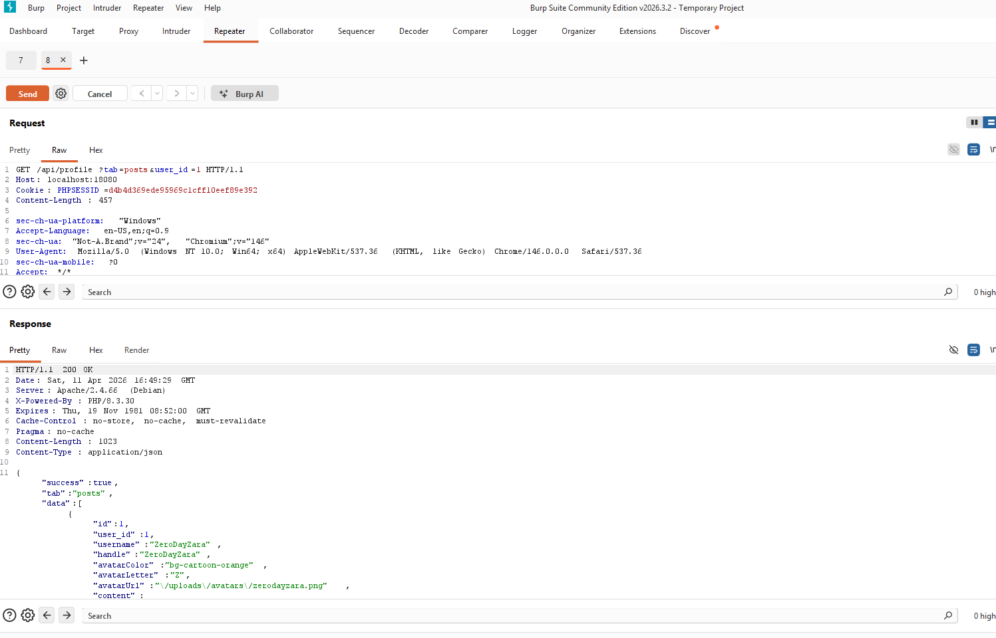
Impact:
- Unauthorized access to user data
- Privacy violation
- Possible flag exposure

Fix:
if ($userId !== $currentUserId) {
deny_access();
}

4. Insecure File Path Handling (Image URL Injection)

Location:
POST /api/posts
image_url=<user-controlled>

Description:
The application trusts user-supplied image_url without validation.

PoC:
image_url=../../../../etc/passwd
image_url=/uploads/posts/post_1.png

Impact:
- Potential path traversal
- Unauthorized file access
- SSRF (if external URLs allowed)

Fix:
- Only allow server-generated paths
- Validate and sanitize inputs

5. Missing Rate Limiting (Brute Force)

Location:
Login endpoint

Description:
No rate limiting or account lockout observed.

PoC:
Multiple login attempts with wrong password show no delay or blocking.

Impact:
- Brute-force attacks
- Credential stuffing

Fix:
- Implement rate limiting
- Add account lockout / CAPTCHA

6. Weak Input Validation (Blacklist Filtering)

Evidence:
[Error: Logic Blocked]

Description:
Application uses blacklist-based filtering instead of proper sanitization.

Impact:
- Bypass possible
- Inconsistent protection

Fix:
- Use whitelist validation
- Avoid pattern-based blocking

Security Controls Verified:

- XSS Protection: HTML properly escaped in profile fields

- SQL Injection Protection: Parameterized queries used

- CSRF Protection: Session cookies not sent cross-origin
<form action="http://localhost:18080/api/posts" method="POST">
<input type="hidden" name="content" value="CSRF_ATTACK_SUCCESS">
<input type="hidden" name="is_private" value="0">
</ -form> - Not worked

